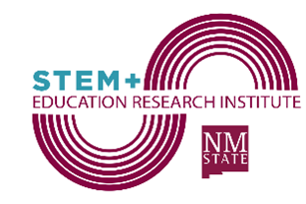
STEM+ Education Research Institute (SERI)
New Mexico State University

Mission of SERI: To create a locus for STEM+ Ed research excellence that attracts talented faculty and staff, stimulates research, and fosters collaboration at New Mexico State University.
SERI Membership Form
Institute membership will be active for three years, and renewal will be contingent on ongoing participation in activities germane to the mission of the Institute. Institute participants will act as principal investigator, co-principal investigator, support person, or collaborator on at least one funded institute project or submitted proposal during any 3-year membership period.

Name and Signature of New SERI Member: ______________________________

NMSU College and Department: ________________________________________

Recovered indirect cost funds represent a means for the strategic growth of the Institute and will also fund a portion of the operating costs (e.g., management team staff). Therefore, indirect costs that are usually allocated to the college (i.e., 44.325% of the total recovered IDC) will be split between the participating college(s) (70%) and the Institute (20%), and the PI(s)(10%). Only grants submitted that emphasize SERI’s mission will be contributing to the Institute.

Department Chairperson’s Signature: ___________________________________

Dean of the College’s Signature: ___________________________________

Date: _________________
(Please return the signed form to Dr. Susan Brown, Interim Director of the STEM+ Education Research Institute, susanbro@nmsu.edu)

